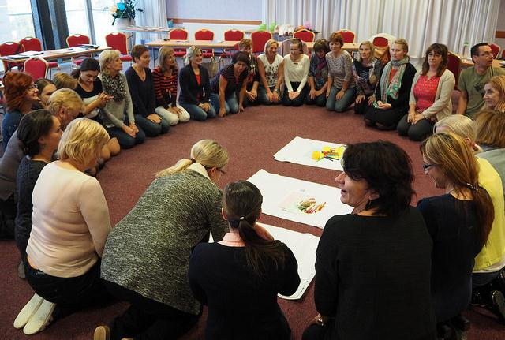
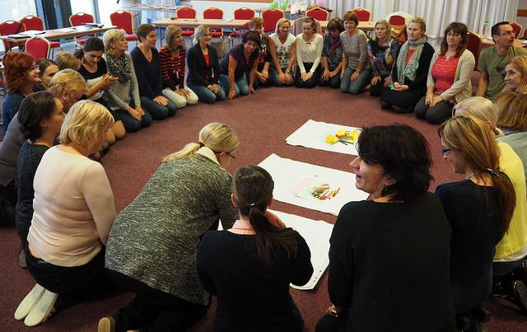
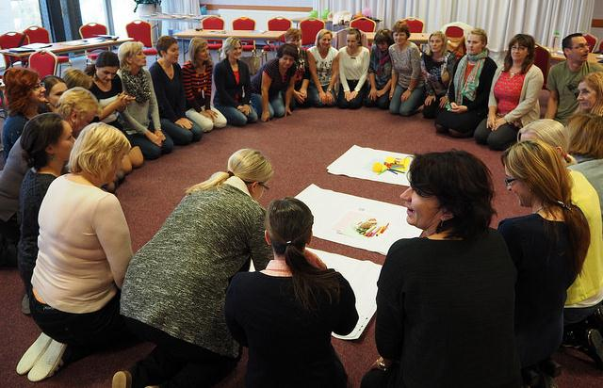
APPLICATION
FORM
DEMOCRATIC SCHOOLS FOR ALL

The Autumn Academy

Bratislava, Slovak Republic
18 – 21 October 2017
Organized by the National Institute for Education, Slovak Republic in cooperation with the Council of Europe, the European Wergeland Centre.
The Academy is organized with the support of the Ministry of Education, Science, Research and Sport, Slovak Republic.

APPLICATION FORM

Complete and send the application form in WORD format by 14 July 2017 to:
Ms Michaela Ujházyová: michaela.ujhazyova@statpedu.sk and CC to
Ms Denisa Ďuranová: denisa.duranova@statpedu.sk

Only team leaders of the successful teams will be notified via e-mail by 18 July 2017.

For further information on the application process contact Ms Ujházyová and Ms Ďuranová at the above mentioned e-mail addresses.

Team Leader (choose one of 3 team members)
Name:
Surname:
Tel (with a country code):
E-mail:

Part 1 General Information

INFORMATION ABOUT THE SCHOOL:..

School name:
School head:
Address:

E-mail: Tel (with a country code):

School profile/orientation of the school education programme (100 words max.):

1
INFORMATION ABOUT THE SCHOOL TEAM MEMBERS:
Member 1: School head / deputy / head of subject committee
Name: Surname:
Position at school:
Years of experience as a school head (deputy) at elementary school:
Teacher of the educational subject:
Years of experience as a teacher:
Qualification(s) and education specialization:
Working language (mark the CEFR level of your language skills): 0 / A1 / A2 / B1 / B2 / C1 / C2
E-mail: Tel (with a country code):

If you attended other trainings on democratic citizenship and/or human rights education, please list them here:

Do you have previous experience in working with education for democratic citizenship and/or human rights education (EDC/HRE)? If so, please describe them shortly:

Member 2: Teacher
Name: Surname:
Teacher of educational subject:
Years of experience as a teacher:
Qualification(s) and education specialization:
Working language (mark the CEFR level of your language skills): 0 / A1 / A2 / B1 / B2 / C1 / C2
E-mail: Tel (with a country code):

If you attended other trainings on democratic citizenship and/or human rights education, please list them here:

Do you have previous experience in working with education for democratic citizenship and/or human rights education (EDC/HRE)? If so, please describe them shortly:

2
Member 3: representative of NGO/municipality/parent/teacher

Name: Surname:
Representative of: NGO / municipality / parent / teacher:
Working language (mark the CEFR level of your language skills): 0 / A1 / A2 / B1 / B2 / C1 / C2
E-mail: Tel (with a country code):

If you attended other trainings on democratic citizenship and/or human rights education, please list them here:

Do you have previous experience in working with EDC/HRE? If so, please describe them shortly:

NB:
If the 3rd member is a representative of NGO/municipality, please, specify:

Name and legal form of the organization:
Address:
E-mail: Tel (with a country code):
Specialization/area of action:
Years of experience in NGO sector (if applicable):

If the 3rd member is a teacher, please, specify:
Qualification(s) and education specialization:
Teacher of educational subject:
Years of experience as a teacher:

3
Part 2 Additional Information

Please note that the selection will be based on your answers to the questions below. Discuss your answers in your team. Keep in mind to be short and precise in your answers.

- What motivates you to participate in the Academy? (100 words max.)

- What are your ideas for implementation and dissemination upon returning to your school? (in what part of the school life, in cooperation with organization(s) or schools, time period) (200 words max.)

- Describe specific activity you would like to realize at school upon your return. (200 words max.)

- In case you have experience in the field, describe an example of good practice in building democratic school environment. In case you haven’t had possibility to gain such experience, describe your vision and plans which could be supported by Regional Academy. (200 words max.)

4
Part 3 Responsibilities

The Slovak Autumn Academy will be held by a team of trainers with international and national experience, thus the working language of the training is English with interpretation provided when needed. However, all participants should have basic knowledge of the working language and at least one member of the team knowledge at the language level B2 of the CEFR to be able to participate actively in the training.

We are aware of the fact that the Academy is an intensive training programme which includes the development of an EDC / HRE project that will be implemented in our school until 31 March 2018. That is why we declare our readiness to participate actively during the whole duration of the educational course, including preparatory tasks in 1 - 17 October 2017, the in-person training on 18 - 21 October 2017, and the project implementation phase which includes evaluation and lasts until 31 May 2018.

Each year, the organizers take photos during the Academy, and some of them are used for promotion purposes (e.g. website, promotion leaflet). We agree that pictures where we feature might be used for promoting the Regional Academy:
Yes: ____ No: ____

I hereby give consent for my personal data included in my application to be processed in accordance with the Act No. 122/2013 Coll. on the Protection of Personal Data by the National Institute for Education for the purposes of the selection process, realization of the educational programme, promotion and information about the Regional Academy 2016 Programme. My consent includes providing the data to third parties for the purposes of the selection process. I am aware that processing my personal information will conform the Act No. 122/2013 Coll. on the Protection of Personal Data as amended, especially §28, which regulates my rights to protect my personal information.
Date: ____________________
Full name of the school head of the school: ____________________

1. Member of the school team
Full name: ____________________
2. Member of the school team
Full name: ____________________
3. Member of the school team
Full name: ____________________

